**Factory Reset**

**Purpose:**

when you get a new Pa220 firewall, it may have a config already saved on it or you nuked the configuration so bad that you must reset it so you can start over or make it for a different purpose than it already was

**Background:**

A firewall is a device that blocks things from coming into your network and allows the utmost safety and every big company uses one or many to keep their information safe. And in this lab, we factory reset it to get in ready for configuration.

**Steps**

**#1**

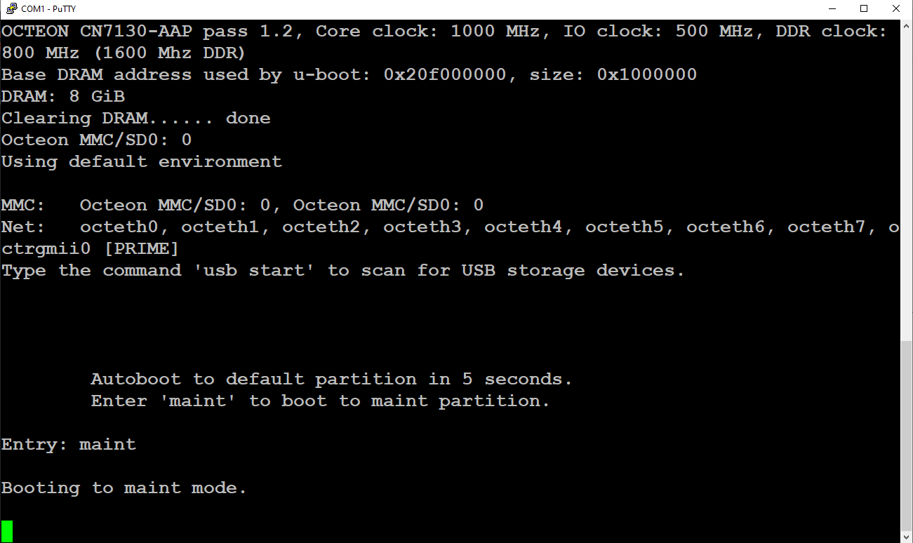

**Console in and wait for fire wall to boot up and when it does type “maint” to go to next spet**

**#2** 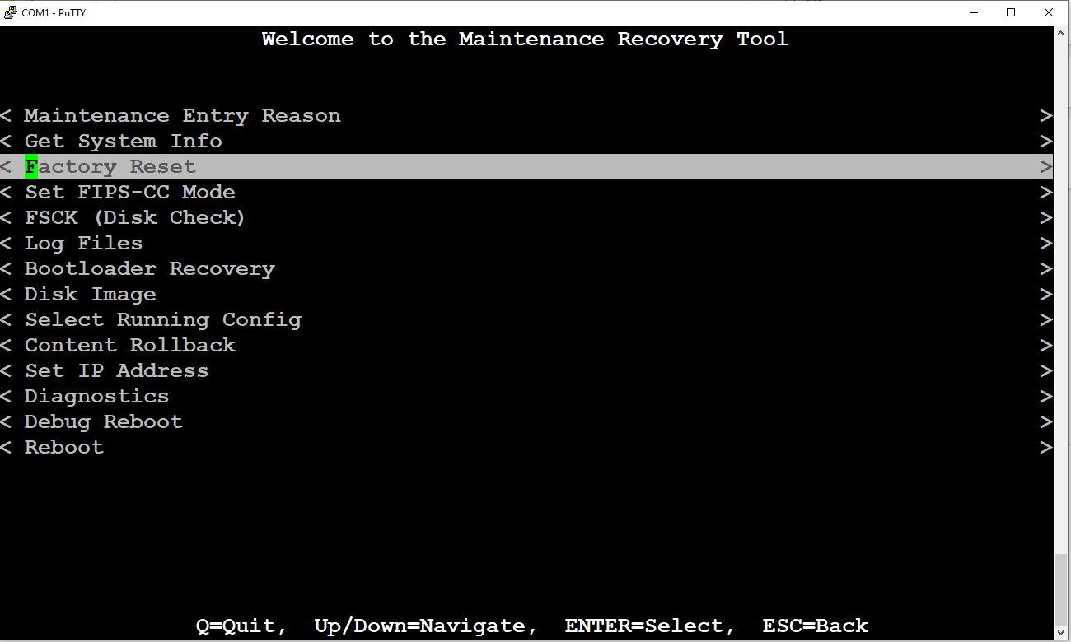

**Once you are in the maintenance menu select factory reset**

**#3**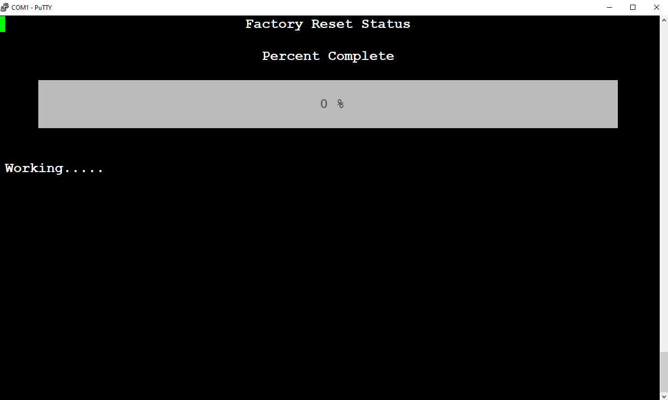

**Wait for reset status to go 100%**

**#4** 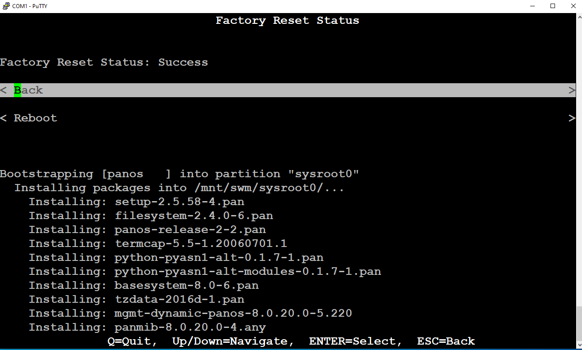

**Exit out of factory reset stats**

**#5**

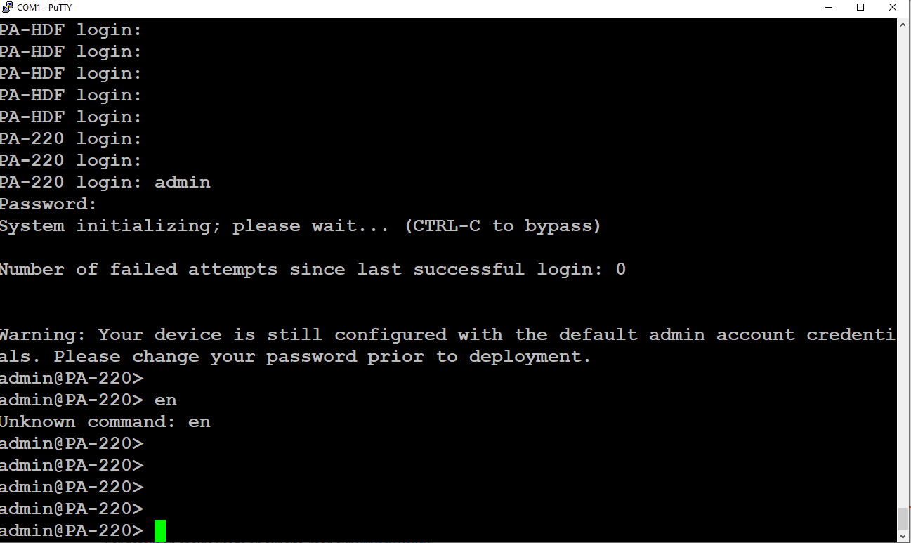

**#5**

**Hit enter and wait for Pa-220 Login prompt**

**(Username: admin, password: admin are default)**

**#6**

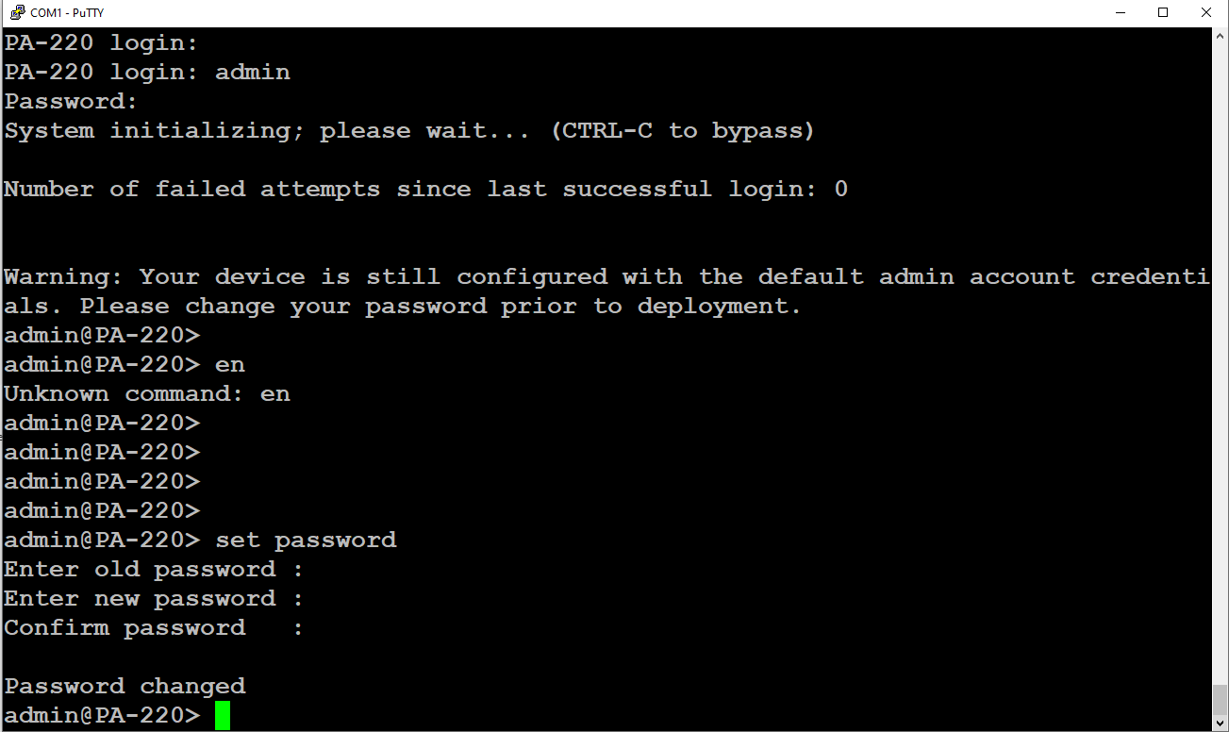

**Type “set password” after you have logged in to set your new password**

**Problems:**

We did not type “main” fast enough

We treated the firewall like a router, but it wasn’t

**Conclusion**

In this lab we factory reset a Pa220 firewall so we can start from fresh and configure it to our liking